Notes for DRIFT: Receiving and sending updates
This note provides guidance for updating and operating the DRIFT DSS. It covers the following aspects:
1 Updating the DRIFT*.exe (executable file / application) 1
1.1 If there is an error on opening the DRIFT software 1
2 Updating the DB in the DRIFT-DSS (when sent a new “DB Master”) 2
3 Sending updates back to Alison 3
3.1 Sending the Export file 3
3.2 Sending the updated DB 4

Updating the DRIFT*.exe (executable file / application)
All the DRIFT.exe files are date-stamped and will stop working when the stamp date is reached. This is to ensure that you are always working with the latest version of the DSS software, as changes are being made constantly to align the DSS to the needs of the Council Study.

Thus, from time to time, we will provide you with a new version of the DRIFT DSS software. This file will be called DRIFT*.exe, where the * represents the version of the software.

When you receive an updated DRIFT.exe, you should:
- DELETE the old version
- Download the zipped * .exe software from Dropbox
- Paste it into the C:\DRIFT\Bin folder
- Unzip it directly into this folder, so that the folder looks like this:
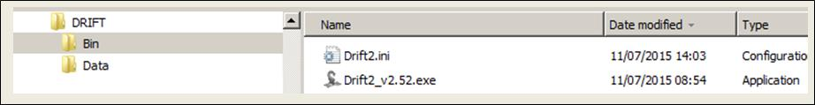

If there is an error on opening the DRIFT software
When you open the updated DRIFT*.exe, it may fail to connect with the MekongCouncilStudy database, and will instead give you an error message. If this happens:
- Click “Ok” or “Continue” (depending on the error message).
- Then click “Project”, “Select project” (See 1 below), and browse to the C:\DRIFT\Data\MekongCouncilStudy folder (See 2 below). Click (once) on the C:\DRIFT\Data\MekongCouncilStudy folder and then click “Ok”.
- Then CLOSE and reopen the DRIFT DSS.

1.  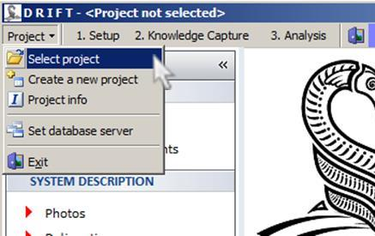 | 2.  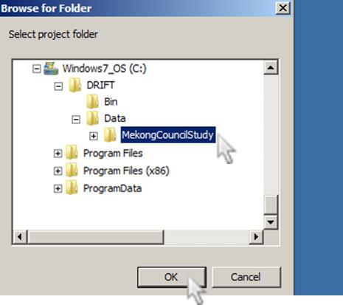

Updating the DB in the DRIFT-DSS (when sent a new “DB Master”)
The information in DB in the C:\DRIFT\Data\MekongCouncilStudy folder will change considerably as you and others work on their response curves. This means that, from time to time, we will issue an updated DB, which will integrate the work done into a single updated DB.

When you receive an updated DB, you should:
- Download the zipped “DB” folder from Dropbox. It will usually be named:
“DB Master ddmmyyyy hhmm.zip”
- Paste it into the C:\DRIFT\Data\MekongCouncilStudy folder (see example circled in blue below)
- Copy & paste the contents of zipped “DB” folder so that you overwrite the contents of the DB folder in C:\DRIFT\Data\MekongCouncilStudy (see folder circled in red below)
There are 46 files in C:\DRIFT\Data\MekongCouncilStudy\DB that you must overwrite. If your computer does not ask you if it should overwrite, then you are pasting / unzipping to the wrong place
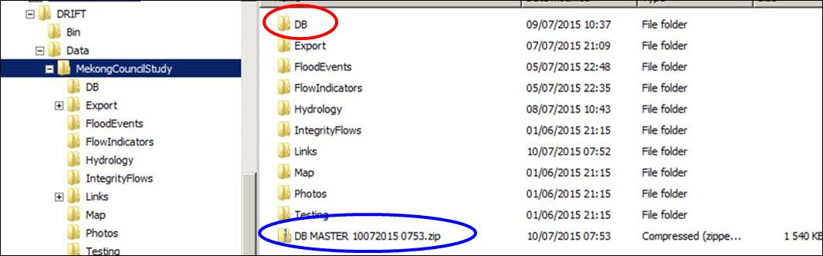

Sending updates back to Alison
Once you have made changes to your indicators, links, response curves, or started a new site, please send us the Export files AND an updated DB.

Sending the Export file
- Go to “Knowledge Capture” and then to “Export / Import” (under “Response Curve” heading)
- (See images 1 and 2 below for navigation)

1.  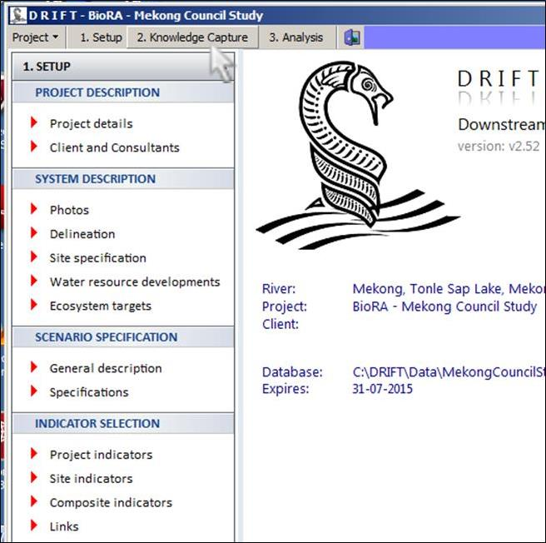 | 2.  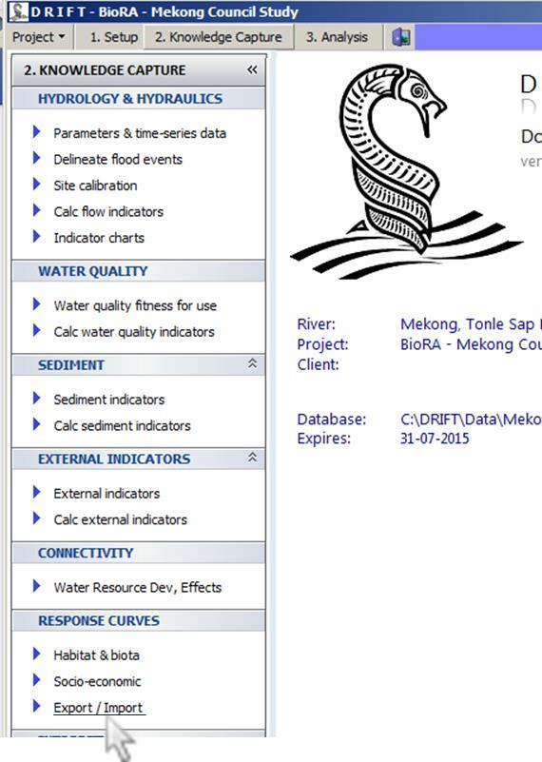
3.
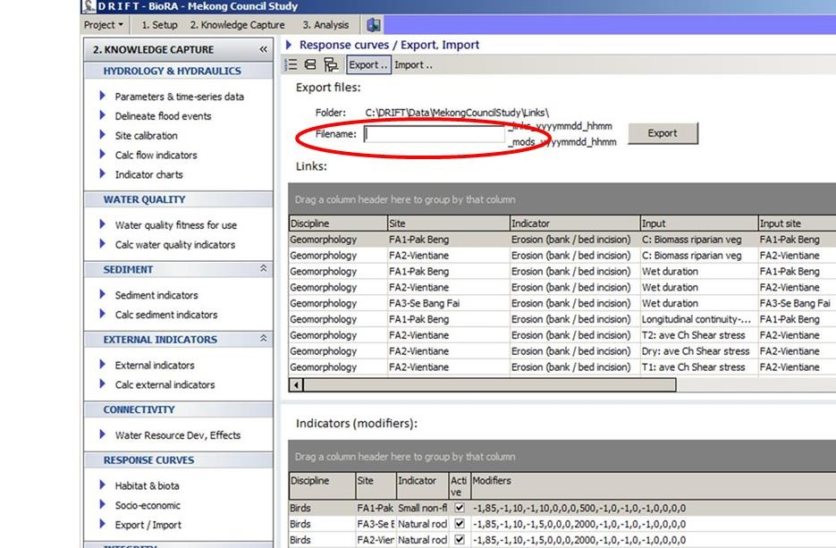
4.
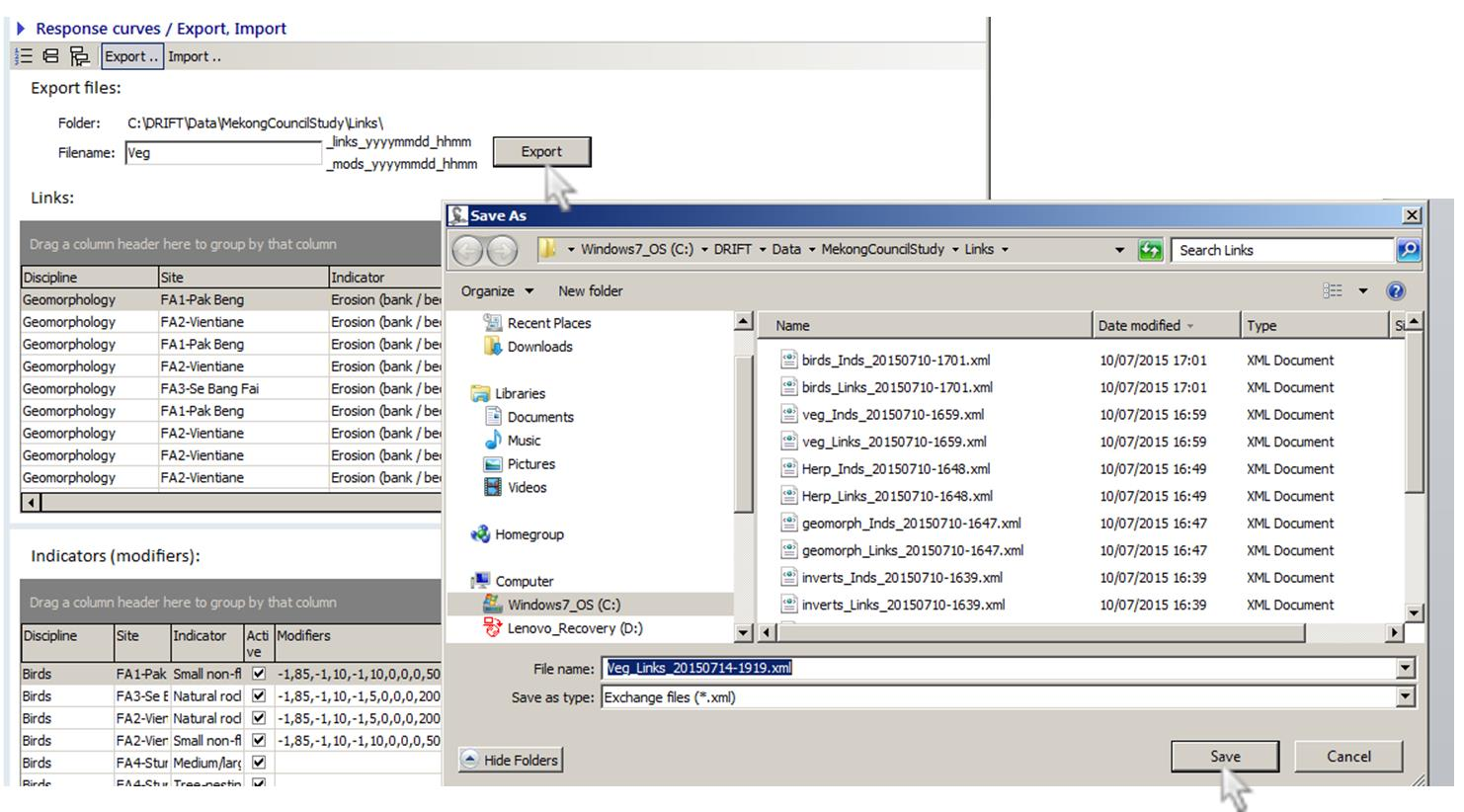

- When you’ve clicked on “Export/Import” your screen should look something like 3.
- Ignore everything else and type the name of your discipline in the space provided (shown in red circle in 3), e.g., “Veg” or “Geomorph”. The date and time will be filled in automatically.
- Click on the “Export” button to the right of the file name you typed.
- The DSS will automatically display the C:\DRIFT\Data\MekongCouncilStudy\Links folder (see 4).
- Click on “Save” (see 4).
- When you have done that, close the DSS, and go to the C:\DRIFT\Data\MekongCouncilStudy\Links folder.
- Copy the two latest files relating to your discipline to Dropbox and alert Alison to their presence. (If the files are small enough you may prefer to zip and email them). [The relevant files will be the most recent in the C:\DRIFT\Data\MekongCouncilStudy\Links folder, and their names will be, for example, “Veg_Inds_yyyymmdd-hhmm.xml” and “Veg_Links_yyyymmdd-hhmm.xml”].

Sending the updated DB
- With the DSS closed, zip up the C:\DRIFT\Data\MekongCouncilStudy\DB folder.
- Rename the zipped folder “DB_discipline_ddmmyyyy” (e.g. “DB_Veg_03072015.zip”) and load to Dropbox and alert Alison to their presence. (If the files are small enough you may prefer to zip and email them).

